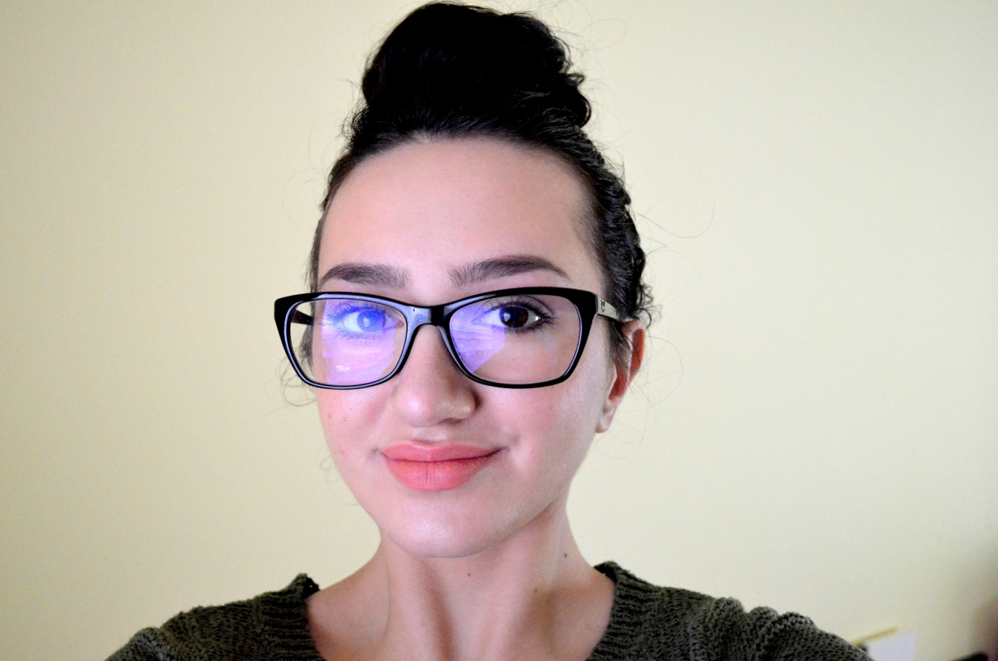

My name’s Soňa Husárová, I’m 15 years old and I live near Poprad. I’m very ambitious, honest, positive and optimistic. My favourite activities are learning about history, but also painting, drawing, hanging out with friends, playing with my dog. I like to educate myself by learning new languages, it’s my favourite activity.